Submitting Documents to the Trustees Sharepoint Site
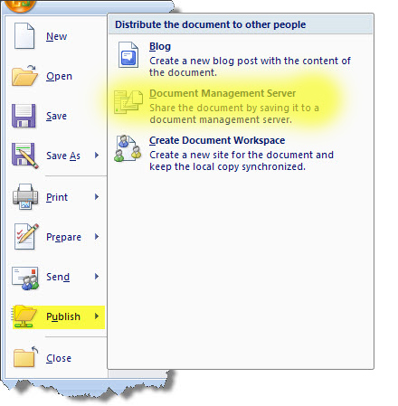
- Create your document in word
- Select the Office Button
- Select Publish
- Select Document Management Server
- In File Name:
  - First time: copy and paste:
https://trustees.wwu.edu
  - OR after first time: select My Network Places from the Save in: list on the left of the screen and then select https://trustees.wwu.edu
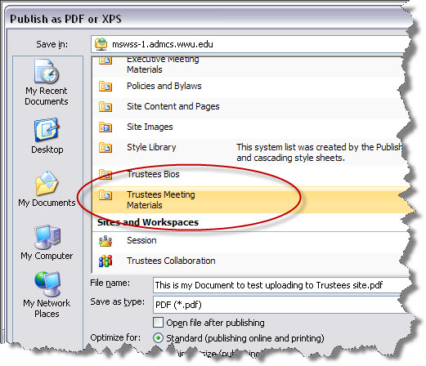
- You’ll see the Sharepoint site appear in the file window. Scroll down the list to Trustees Meeting Materials and double click
- Change the File Name to reflect the agenda numbering such as
“IV a Department Reports Alumni Relations” or whatever would uniquely identify your submission.
- Change Save as type: to PDF
- You may get a message saying the document can’t be saved because data is missing. Select OK and the document properties selectors will be loaded into your word document like this: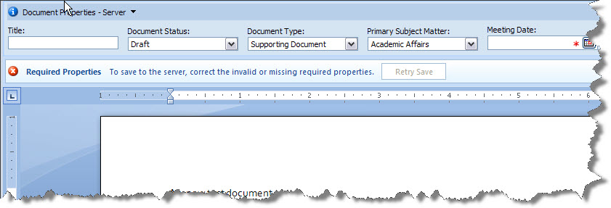
  - Title: should be exactly the same as the agenda item such as
“IV a Department Reports Alumni Relations” or whatever would uniquely identify your submission.
  - Document Status: must remain Draft. DO NOT change this.
  - Document Type: select the appropriate section of the meeting such as Agenda or Consent Item.
  - Primary Subject Matter: This should be the division your material is representing.
  - Meeting Date: The date of the Board Meeting this document will be presented at.
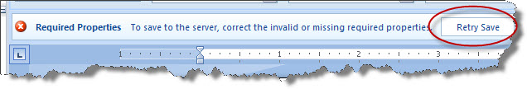
- Then select the Retry Save button that is directly below the Document properties panel.
- That’s it. Liz will get an email telling her your document has been submitted. She will change your document status to Current when it is ready to be viewed by the public.
- View the live site at http://trustees.wwu.edu .

Notes:

If you don’t have Office 2007 – talk to Software Services and get it installed.

If you don’t see PDF as an option to save as – get the add-in for Office 2007 http://www.microsoft.com/downloads/details.aspx?FamilyId=4D951911-3E7E-4AE6-B059-A2E79ED87041&displaylang=en ; click ‘Continue’, install Active X Control if requested, click ‘Download’ when presented, then follow prompts to complete installation.

